2Purposes | Nursery | Reception | Year 1 | Year 2 | Year 3 | Year 4 | Year 5 | Year 6
To Entertain |  | - Letter formation  - Create a story orally  - Sentence writing | - Labels and captions  - Description  - Story  - Poetry | - Description  - Story retell  - Poetry | - Description  - Story  - Poetry | - Description  - Story  - Poetry | - Description  - Story  - Poetry | - Description  - Story  - Poetry
To Inform | - Write name  - Writing has a purpose | - Caption writing | - Labels and captions  - Recount  - Instructions  - Letters | - Recount  - Letter  - NC Report  - Instructions | - Diary  - Letter  - NC Report  - Instructions  - Explanation | - Diary  - Letter  - NC Report  - Instructions  - Explanation | - Diary  - Letter  - Report  - Explanation | - Diary  - Report  - Letter  - Explanation  - Biography
To Persuade |  |  |  |  | - Advert  - Letter | - Letter  - Speech | - Letter  - Speech | - Letter  - Speech
To Discuss |  |  |  |  |  |  | - Argument  - Review | - Argument  - Debate  - Review

 | Nursery Writing Overview
To Inform | Children begin to understand that writing has a purpose | Children begin to develop the skills of an early writer | Children write all of their name
 | Adult models how to use print for a purpose alongside pictures.  Adult actively encourages and promotes the use of print, not just pictures, both in adult led and child initiated learning.  Children write for a purpose independently in the learning environment. For example, letters to Santa, a shopping list, a birthday card.  Begin to mark make their name. | Writing is given a high profile across all staff members. All children are targeted to engage in mark making on a regular basis.  Children will increasingly independently use print in their child-imitated learning. Adults provide a range of exciting opportunities to write across all areas of the provision.  Children begin to form the first beginning letters to the name with adult support and modelling through weekly adult guided groups. Correct formation of letters is modelled from the start. | Children further develop their formation from the previous stage, through a range of name card materials.  Adults begin to ‘step back’ from recording children’s names on pieces of learning.  No adults to be writing children’s names on learning.  Children are supported with name prompts to have ‘a go themselves’. In order to make progress, children regularly respond to oral feedback.  Children can write their name and find aids to support their name writing. Children begin to show an awareness of how the letters in their names are correctly formed.

 | Reception Writing Overview
Write | Children have the segmenting skills to independently write CVC words, using their developing set 1 single sounds phonic knowledge | To be secure in set 1 single sounds and beginning to develop set 1 special friends phonic skills. To begin to use finger spaces and break the flow of speech into words | Write simple phrases and sentences that can be read by others including some set 2 digraphs and trigraphs and tricky words.
 | Children have a developed grapheme/phoneme correspondence of set 1 sounds.  Children have support with letter formation. Children have quick and accurate grapheme/ phoneme correspondence and begin to segment CVC words with adult support.  Children are developing more independence with letter formation. Children independently segment and record CVC words using strong and quick grapheme/ phoneme correspondence.  Children are developing more independence with letter formation. | Adult to model caption writing, exposing to more than one word. Children to orally rehearse a sentence.  Children develop individual letter formation next steps based on letter formation families.  Dictated caption using blocks to represent individual words. Finger spaces represented by gaps.  Children develop individual letter formation next steps based on letter formation families.  Children begin to use finger spaces more independently. Children begin to include digraphs in their writing with special friends sound mat support.  Children begin to respond to written letter formation feedback | Children begin to link uppercase and lowercase letters and begin to develop formation of capitals.  Children to spell phase 2 tricky words independently.  Children use ‘ng, th, ch, sh’ in CVC words.  Guided adult group support with dictated sentence to correctly include capital letter, finger spaces and full stops.  Children continue to develop knowledge of digraphs and trigraphs in their writing.  Children record independent sentences including a capital letter, full stop and finger spaces.  Children are able to identify whether it is a digraph or trigraph needed in their writing.

Year 1 Writing Overview
Autumn 1 | Autumn 2 | Spring 1 | Spring 2 | Summer 1 | Summer 2
Short Write – Sentence focus (Bumble Bear - 3 week)  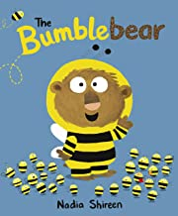  R – Focus on sentence construction  A - Teacher  F – 1.2, 1.5, 1.6  T – formal | Poetry (Bonfire Night – 1 week)  R: To entertain  A: Parents  F: 1.24  T: Informal | Non-chronological page (In the Past – Toys 3 weeks  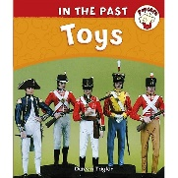  R – To inform how to use a toy  A – Library  F – 1.5, 1.6, 1.23  T – formal | Character Descrition (How to wash a Woolly Mammoth- 2 weeks)  R –Entertain  A – Peers  F – 1.1, 1.23  T – Descriptive  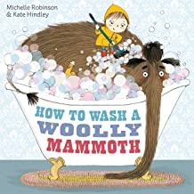 | Retell a narrative (Traction Man - 3 weeks)  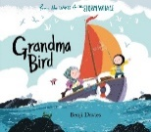  R – Entertain  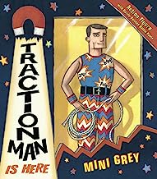  A – Parents  F – 1.7, 1.9, 1.13  T – descriptive entertaining | Retell a narrative (Superworm – 3 weeks)  R – To entertain  A – Reception  F – 1.1, 1.9, 1.13  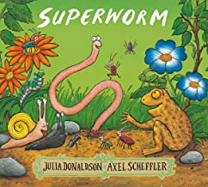  T – Descriptive
Narrative (Rescue story – 3 weeks)
R – To entertain
A - Peer
F – 1.1, 1.13, 1.14
T – descriptive

Character description - Wanted Poster (Bumble Bear - 3 week)  R – Warn readers about the bear.  A - Peer  F – 1.2, 1.5, 1.6  T – formal | Setting description: (Stickman – 3 weeks)  R: Describe a scence  A: Share with EYFS  F: 1.9,.  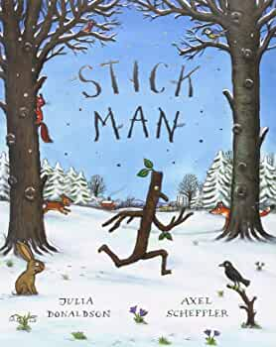  T: Formal | Non-chronological page (Ways into Science – Everyday Materials 3 weeks)  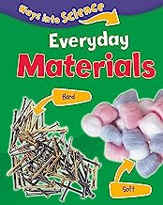  R – Inform about materials  A – Other Y1 Class  F – 1.5, 1.6, 1.7  T – Formal, factual |  | 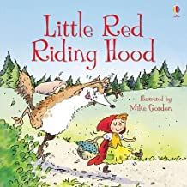  Retell a narrative (Little Red Riding Hood – 2 weeks)  R - Entertain  A - Peers  F – 1.7, 1.13, 1.14  T – descriptive, entertaining
Instructions (How to wash a Woolly Mammoth 4 weeks)
R – To inform
A – Y2
F – 1.5, 1.6, 1.8
T – Informal

 | Letter to  Santa (Stickman 3 weeks)  R – Inform Santa  A - Santa  F – 1.7, 1.5, 1.6, 1.11  T – Formal |  |  | 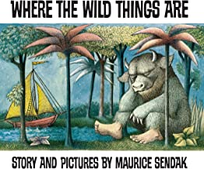  Retell a narrative (Where the Wild Things Are – 2 weeks)  R - Entertain  A - Peers  F – 1.7, 1.13, 1.14  T – descriptive, entertaining
Writing for Pleasure - Take One Picture
1 week
https://www.nationalgal lery.org.uk/learning/take-one-picture
F: Links to learning ladder
Year 2 Writing Overview
Autumn 1 | Autumn 2 | Spring 1 | Spring 2 | Summer 1 | Summer 2
Short Write – Character Description (Little Red - 1 week)  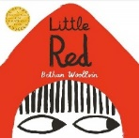  R – Familiarise the reader  A - Peer  F – 2.1, 2.7, 2.10  T – formal | Recount: Bonfire Night  2 weeks  Experience using sparklers/warm clothing/hot chocolate  R – Inform parents  A – Parents  F – 2.22, 2.16, 2.18  T – Informal | Recount (Diary - Vlad and The Great Fire of London -  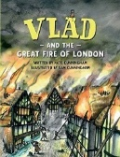  3 weeks  R – Share experience  A – twitter  F – 2.5, 2.6, 2.10,  T – informal | NC Report (Marine Animals - 3 weeks)  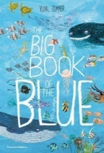  R –Inform  A – Visitors to Blue Planet Aquarium  F – 2.22, 2.5, 2.2  T – formal factual | Setting Description and Narrative – adventure (Grandma Bird - 3 weeks)  R – Entertain  A – Y2  F – 2.22, 2.9, 2.4  T – descriptive entertaining | 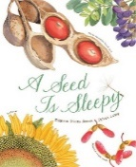  Instructions (How to grow a sunflower - 2 weeks)  R – inform  A – friend  F – 2.16, 2.11, 2.6  T – formal, advisory
Recount (School trip – 2 weeks)
R – share experience
A - parent
F – 2.5, 2.3, 2.8
T – friendly, informal
Narrative: Retell (Red Riding Hood – 2 weeks)  R – Entertain  A – Y1 / Reception  F – 2.3, 2.4, 2.17  T – Descriptive / formal | Poetry – using sound words (1 week)  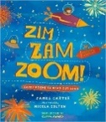  R - Entertain  A - Reception  F – 2.23, 2.25  T – Informal / funny | NC Report (Who was Samuel Pepys? 2 weeks) BBC Bitesize video  R – Inform  A – Y1  F – 2.8, 2.5, 2.2  T – Formal, factual |  | 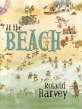  Recount (Postcard from a beach setting)  R – share experience  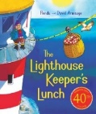  A - friend  F – 2.3, 2.2, 2.5  T – friendly, informal
Narrative (Flotsam – 2 weeks)
R - Entertain
A – Y2
F – 2.15, 2.22, 2.11
T – descriptive, entertaining
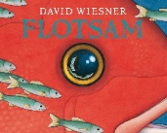
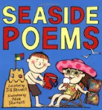
Poetry (1 week – seaside poems)
Word choice focus

Instructions: How to Make an Indian Dessert (3 weeks)  R – Instruct  A – parents  F – 2.18, 2.21, 2.4  T – assertive | Setting Description (1 week) – Paddington’s Christmas Post | Letter (King Charles – fire safety – 2 weeks  R – Improve safety  A – King  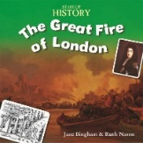  F – 2.22, 2.25  T – formal,  advisory
 | Narrative (2 weeks)  R – Entertain  A – Peer  F – 2.4, 2.6, 2.9  T - Formal |  |  |  | Writing for Pleasure - Take One Picture  1 week  https://www.nationalgal lery.org.uk/learning/take-one-picture
F: Links to learning ladder

Year 3 Writing Overview
Autumn 1 | Autumn 2 | Spring 1 | Spring 2 | Summer 1 | Summer 2
Setting description (The Grotlyn) 2 weeks  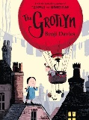  R: Build a picture  A: Peer  F: expanded  noun phrases  T: formal, descriptive | Dialogue: Escape from Pompeii – speech between characters (2 weeks)  R: Add dialogue to text  A: Peer  F: 3.9, 3.13, 3.18  T: Informal | Character description – 3 dragons / pet shop. (Harry Potter, literacy shed) 2 weeks  R: To inform  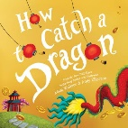  A: Customer  F: 3.1, 3.17  3.20  T: Formal,  warning | Persuasive writing (Someone Swallowed Stanley)  R: Persuade families to recycle  A: Children and parents at CLPS, twitter  F: 3.1, 3,13 3,19  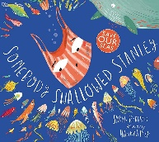  T: persuasive and passionate | Explanation: Teacher Pleaser Machine (2 weeks)  R: Explain how the machine works  A: Peers  F: 3.3, 3.22, 3.5  T: Formal | Setting description: Journey – describe the castle  R: To build a picture  A: Peers  F: 3.10, 3.19  T: descriptive, detailed.
Naarrative Journey (Aaron Becker) the sequel
R: publish a class book:
A: friend
F: 3.9, 3.10, 3.18
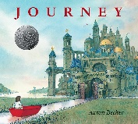
T: entertaining, suspenseful, descriptive
Stone Age Boy  Non-chronological report - Survival Guide (3 weeks)  R: Inform how to survive  A: Stone Age boy  F: 3.4, 3.7,  T: Impersonal, friendly, informative | Narrative: Escape from Pompeii (Use stimulus video to retell eruption) 3 weeks  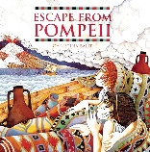  R: Entertain  A: Year 2  F: 3.1,. 3.7,  3.9  T: Formal,  descriptive | Instructions How to trap a dragon (3 weeks)  R: To inform  A: Peer (dragon hunter)  F: 3.6, 3.8, 3.13  T: Formal, Bossy |  | Diary Entry (Crackiing Contraptions) Invention gone wrong (2 weeks)  R: Recount of what went wrong  A: Partner class  F: 3.4, 3.6, 3.13  T: Informal
Non-chronological report: Virtual visit to Recycling centre / Planet full of Plastic / What a Waste
R: To inform
A: Mr Hughes – encourage recycling
F: 3.7, 3.19, 3.20, 3.21
T: formal, persuasive
Postcard from the Stone Age boy to home  R: Inform  A: Parents  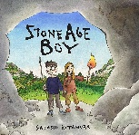  F: 3.7, 3.8,  T: informal | 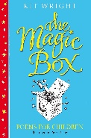  Poetry – Kit Wright Magic Box  R: To entertain  A: Assembly KS2  F: Simile,  Metaphor  T: informal, emotive | 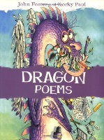  Poetry – Dragons John Foster (twinkl resources) 1 / 2 weeks  R: To entertain  A: Peer  F: Simile,  Metaphor  T: Informal,  descriptive |  | Izzy Gizmo – Narrative (2 weeks)  R: Entertain  A: Twitter  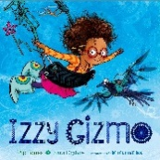  F: 3.5, 3.9  T: Funny,  entertaining
Writing for Pleasure - Take One Picture
1 week
https://www.nationalgal lery.org.uk/learning/take-one-picture

F: Links to learning ladder

Year 4 Writing Overview
Autumn 1 | Autumn 2 | Spring 1 | Spring 2 | Summer 1 | Summer 2
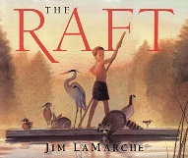  The Raft  Setting  description (3 weeks)  R: To entertain  A: Other Y4 class  F: 4.1, 4.7, 4.9  T: formal and descriptive | 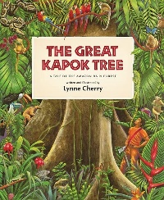  The Great Kapok Tree  Animal  behaviour description (2 weeks)  R: To  inform  A: Teacher  F: 4.9, 4.6  T: Formal, descriptive | Highwayman  Persuasive writing (4 weeks)  R: To persuade  A: Police officer  F: 4.9, 4.7, 4.10.  T: Formal  and  persuasive | Street Child  Conversation between two characters (2 weeks)  R: To entertain  A: Y4 friend  F: 4.8, 4.10, 4.3  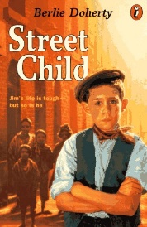  T: informal, friendly | Richard 111  Character description of Richard 111.  R: To describe  A: Peer  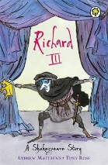  F: 4.17, 4.5,  T: Formal | Alma  Narrative (2 weeks)  R: To scare  A: Class campfire story telling  F: 4.17, 4.16, 4.15  T: Formal and tension building
Mr Wuffles (3 weeks)
R: To entertain
A: Library
F: 4.1, 4.5, 4.17
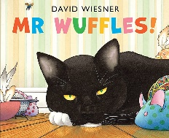
T: Informal and descriptive

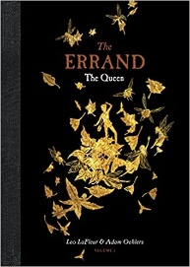  The Errand  Narrative  (3 weeks)  R: To entertain  A: Y3 pupils / library  F: 4.9, 4.6, 4.10  T: Formal and descriptive. | The Great Kapok Tree  Non-chronological Report- Amazon Rainforest  R: To inform  A: WWF  F: 4.11, 4.10, 4.9  T: Formal , informative | Highwayman  Poetry  (2 weeks)  R: To  entertain  A: Twitter/ Y4  F: 4.15, 4.17. |  | Richard 111  Narrative  based on Richard 111 with Anglo Saxon / Viking  R: To entertain  A: Library / parents  F: 4.17, 4.8, 4.7  T: Formal, descriptive
Street Child
Narrative
Recount
(2 weeks)
R: To inform
A: Share with Y3
F: 4.17, 4.16
T: formal / informal

Writing for Pleasure:

Children select own RAFT and write a story of their own choosing. (1 week)
Street Child
Narrative (3 weeks)
R: To entertain
A: Parents
F: 4.5, 4.2, 4.17
T: Formal and descriptive
F: Links to learning ladder

Year 5 Writing Overview
Autumn 1 | Autumn 2 | Spring 1 | Spring 2 | Summer 1 | Summer 2
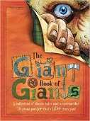  Non-chronological Report – The Under the Bed Giant (3 weeks)  R – Inform  A - Peer  F – 5.2, 5.11  T – formal | Character Description (Stay Where you are and then Leave) – Mr Janacek (2 weeks)  R – Build picture of character  A – Y4  F – 5.8, 5.16  T - informative | Letter: From a soldier home describing life in the trenches  R – Inform home  A - Family  F – 5.5, 5.10, 5.14  T – informal, show emotion | Character Description Wanted Poster – Iron Man – 2 weeks  R – Warn people  A – local community  F – 5.5, 5.7, 5.15  T – formal,  Informative,  descriptive | Setting Description: The Tempest – description of Storm – 3 weeks  R: To describe  A: Peer  F – 5.3, 5.4, 5.14  T – descriptive, shocked  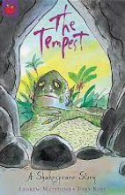  https://www.bbc.co. uk/teach/class-clips-video/english-ks2-the-tempest-home/zfskxyc | Non-chronological Report: Animal found in a zoo (2 weeks)  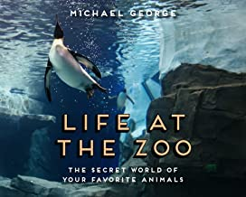  R – Inform  A – Zoo tourists  F – 5.11  T – formal, informative
Description: Setting of Giant Country in BFG (2 weeks) Film and book  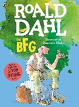  R – Enable Army to recognise place  A - Army  F – 5.1  T – formal / informative | Diary Entry: Alfie’s record of the shop being vandalised (1 week)  R – Record event and responses  A - Self  F – 5.5, 5.7, 5.15  T - informal
Balanced Argument: Should animals be kept in zoos? 3 weeks
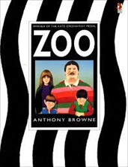
R – To read aloud / inform
A –Y6
F – 5.10, 5.11
T – formal, informative, factual, balanced
 |  |  | Narrative – Retelling of Iron Man Chapter 2 (2 weeks)  R – School library  A – KS2 children  F – 5.4, 5.8, 5.11, 5.6  T – In character (simple language), personal, emotional. | Narrative with dialogue: (Dialogue to convey character – Scene Prospero arguing with Caliban – Use EAST to support) 3 weeks  R: To convey character  A: Display  F: 5.6, 5.16  T: Depends on character  https://www.youtub e.com/watch?v=D0x Pq9mCA-w
Persuasive Text: Persuade British Gov to honour Walter Tull with Military Cross (3 weeks)
R - Persuade
A - Government
F – 5.1
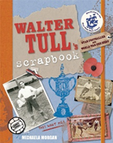
T – Formal, argument-ative,
persuasive

Instructions: Recipe for a dream (1 week)  R – Instruct what makes a good dream  A – BFG  F – 5.3  T – friendly / impersonal | Narrative:  Alternative Story Ending (3 weeks)  R - Entertain  A – Y4  F: 5.2, 5.3, 5.10  T – Formal, descriptive
Writing for Pleasure (2 weeks) See Ross Young WfP for ideas.
Pupils decide RAFT
 | Poetry (Christmas Theme – 1 week)
F: Links to learning ladder
Year 6 Writing Overview
Autumn 1 | Autumn 2 | Spring 1 | Spring 2 | Summer 1 | Summer 2
Wanted Poster (Chracter description)– Who Let the Gods Out (1 week)  R: To create an image of the character  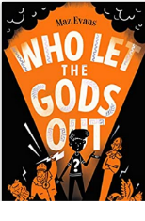  A: Y6 pupils  F: 6.3, 6.13  T: informal,  descriptive | Non-chronological Report – Greatest Showman / Little Freak (3 weeks)  R: To inform  A: Education guide  F: 6.1, 6.4, 6.7  T: formal, factual | Setting description (Alan Walker Faded) 2 weeks  R: To describe  A: Peers  F: 6.5, 6.7  T: Formal, descriptive | Reading to enhance writing focus | Diary Entry - Rose Blanche – 2 weeks  R: To record thoughts and feelings  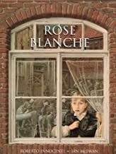  A: Peers  F: 6.3, 6.15, 6.16  T: Informal, emotive | Balanced Argument – Graffiti Art (3 weeks)  R: Present a for and against debate  A: Local Council  F: 6.16  T: Formal, factual
 |  | Inner Monologue (Alan Walker – Faded) 1 week  R: To share inner thoughts  A – Alan Walker  F:  T: Descriptive, informal | Non-Chronological Report (Eid 2 weeks)  R: To inform  A - Library  F: 6.6, 6.9  T: Formal
Narrative –  Who Let the Gods Out (2 weeks  R: To entertain  A: Library  F: 6.2, 6.8, 6.17  T: Formal, descriptive | Character setting – Little Freak (inner monologue ( 1 week)  R: To share inner thoughts of character  A: Peer  F: 6.5,  T: informal, emotive |  |  | Narrative – Rose Blanche – 3 weeks  R: Provide an emotive response  A: Parents  F: 6.5, 6.8, 6.13, 6.15, 6.17  T: Formal, descriptive
Letter (Macbeth)
R: To share feelings and ambitions
A: Lady Macbeth / twitter
F: 6.2, 6.4, 6.12
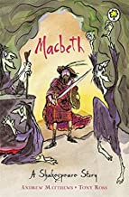
T: Informal, ambitious

 |  | Narrative with flashback (Faded – 2 weeks)  R: To entertain  A - Peers  F: 6.8, 6.15, 6.16  T: Formal, descriptive |  |  | Write for Pleasure (2 weeks unit) – Pupils decide their own RAFT.
Persuasive – Speech (Greta Thunberg speech) (3 weeks)  R: To persuade  A – Parents/ Prime Minister  F – 6.4, 6.11,  T: Persuasive, bossy | Letter – Little Freak – 2 weeks  R: To share feelings  A: Friend  F: 6.6, 6.13, 6.18  T: Informal, emotive |  |  | Poetry (Link to History unit – WW2)  R: Emotive response / empathy  A: Peers  F: 6.16  T: Formal, emotive
Persuasive Speech (Kid President – 2 weeks)
R: To presuade
A: Other Y6 class
F: 6.1, 6.10,
T: Formal, persuasive
 |  |  |  |  | Transition unit (READ)
F: Links to learning ladder

Smart Room Writing Overview
Autumn 1 | Autumn 2 | Spring 1 | Spring 2 | Summer 1 | Summer 2
Character description (Description of emotions – The Colour Monster - 2 weeks)  R: To understand and communicate our emotions.  A: Smart Room  F: cl, fs, adjectives  T: Formal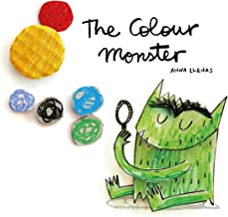 | Character description – Baddies (3 weeks)  R: To entertain  A: Teacher  F: adjectives, and to link ideas  T: Descriptive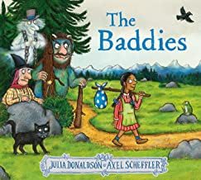 | Inform – New Year’s Resolutions (1 week)  R: To inform  A: Future self  F: exclamation marks  T: Informal | Non-chronological Report – (Bugs 3 weeks)  R: To inform  A: Parents  F: Questions, fs, cl, adjectives, verbs  T: Formal  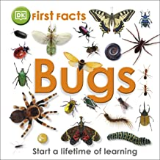 | Narrative – sequence (The Way Back Home)  R: To entertain  A: Peers  F: Adjectives, cs, fl, use of and.  T:  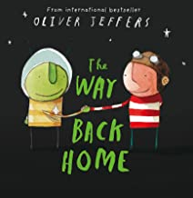 | Instructions (How to grow a sunflower)  R: To provide a clear guide.  A: Reception  F: question marks, imperative verbs, adjectives, use of and.  T: Formal and bossy  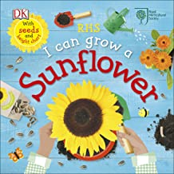
Character description – Can I Build Another Me
R: To entertain
A: Parents / New teacher
F: Re-read and edit
T: Informal, descriptive
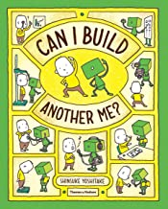
 | Poetry – Bonfire Night (1 week)  R: To entertain  A: Parents  F: Onomatopoeia, adjectives  T: Informal | Narrative (Character Description) – Giraffe’s Can’t Dance (4 weeks)  R: To entertain  A: Teacher  F: Use and to link clauses  T: Formal  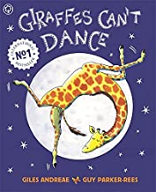 |  | Character description (Supertato)  R: To entertain  A: Library  F: exclamation marks, retell a simple narrative.  T: Formal  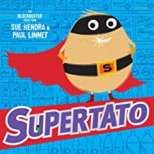
Character description (including emotions) – The Suitcase (4 weeks)
R: To describe emotions
A: Smart Room peers
F: adjectives, cl, fs,
T: Formal
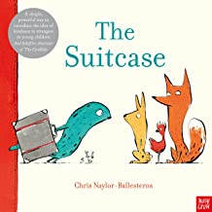
Character description (The Bad Tempered Ladybird – 3 weeks)
R: To describe’ what like’
A: Teacher
F: Adjectives, use of and
T: Formal
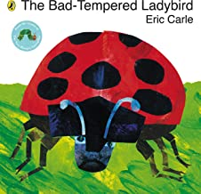
Narrative – Stickman (3 weeks)
R: To entertain
A: Smart Room peers
F: Retell a simple narrative
T: Formal, descriptive 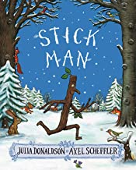
F: Links to learning ladders and Wakefield Progression Scheme

