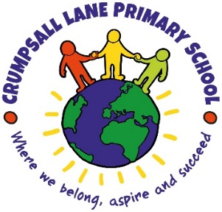

Writing Teaching Sequence

- Predict
Look at the front cover / extract of text or video and discuss predictions.
- Hook
The purpose of the hook is to engage and enthuse pupils. This can be done in the following ways:
- Drama: A range of drama activities, including conscience alley, freeze frame, role-play, hot-seating, etc
- Illustrating a scene from a text: This is a good activity to annotate with speech or thought bubbles, as well as an inference statement linked to the reading
- Using video or images

- Read
Read a model text. Read through and discuss retrieval / inferential questions. Identify features, including language use (use learning ladders). Use the reading into writing grid to discuss how the author impacts on the reader – how does the author build suspense for example. The purpose is for pupils to be able to use these features in their own writing.

- Introduce the RAFT
Introduce the reason for writing, audience, features and tone of writing. This should be visually presented in books and on the working wall. This can be added to the reading into writing grid and should use the learning ladders.

- GPS
Features of text to be taught in context.

- GPS
Features of text to be taught in context.

- Capture
Collect ideas to use in writing. This could be in the form of drama, images, vocabulary, sentence level work.

- Plan
Use the planning format to chunk ideas into sections. Consider which features will focus in which sections of writing. This should include how targets will be met, vocabulary and ideas from the reading into writing grid.

- Write
Teacher models writing then pupils write independently, using their plan to support them. Colourful semantics, text mapping and chunking sections of planning should be used to support pupils with SEND.

- Edit
This is a vital part of the writing process. Pupils must be given the opportunity to:
- edit their work in order to correct grammatical and spelling errors. In Y1 this will be heavily scaffolded by the teacher and focus on correcting basic punctuations and spellings which are appropriate for the pupils’ phonetical level. In Y3, pupils will have a dot in the margin to try and find an error to correct. There will be a clear focus on basic punctuation and spellings from the Y3 and lower curriculum. In Y5 pupils will peer edit to develop their independence. The above will depend on a pupils’ age and stage of development.
- redraft part of their writing for the purpose of improving the impact of a sentence / group of sentences on the reader.
All of the above should be completed following explicit modelling and teaching / retrieval of knowledge.

- Publish
This is also a vital part of the writing process as it reinforces the purpose for writing, which was shared with pupils as part of the RAFT. This could be sharing their work with a peer, sending a letter, publishing on twitter or sharing with an identified audience.

